Music and Memory Study

Stimuli:
- Spoken word
- Lyrics only (a capella)
- Instrumental only
- instrumental and lyrics (whole)

Participants:
- 14 healthy young adults

First fMRI scan – participants listen to all 16 songs in the scanner
Then, participants train on 8 of the stimuli (group A and group B train on 8 different songs)
Second fMRI scan – participants listen to all 16 songs in the scanner (identical scan to first fMRI scan)

Why this project is different than previous studies:
- tightly controlled familiarity manipulation
  - I know exactly how many times each participant has listened to each song
- the familiar and unfamiliar songs are identical
  - control for acoustic differences in the stimuli across familiarity
- stimuli are varied in presence of lyrics and instrumentation
  - can investigate whether behavioural measures of memory vary based on presence/absence of lyrics
  - can investigate what aspects of the auditory stimuli drives synchrony

Why it’s important
- localize areas that are specific to memory for music – if done in older adults and/or Alzheimer’s patients can investigate how this area changes with age/disease
  - may provide insight into why memory for music is spared in late Alzheimer’s
Overall contrasts
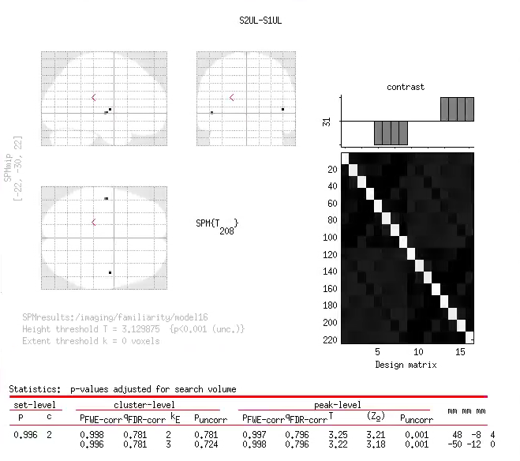
Unlearned songs – Session 2 vs Session 1

Session 2 Learned Songs – Session 1 To be learned songs
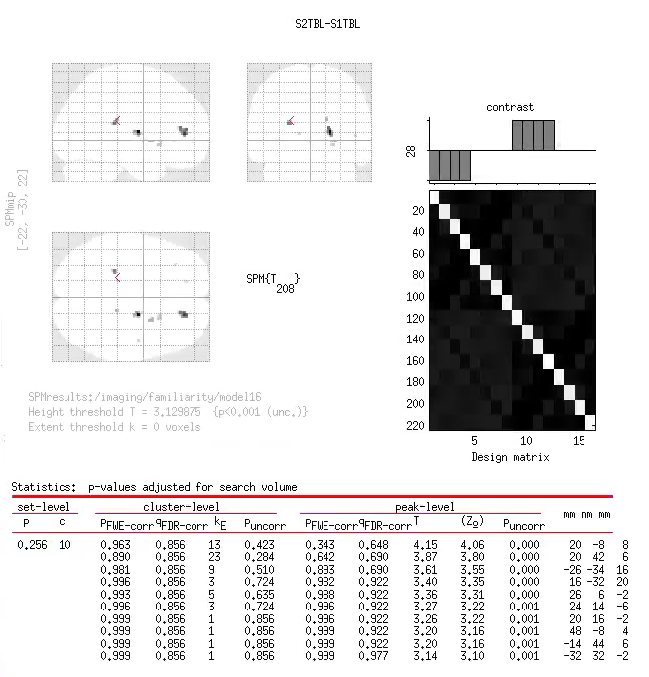
Interaction of session x learned/unlearned x lyrics/no lyrics
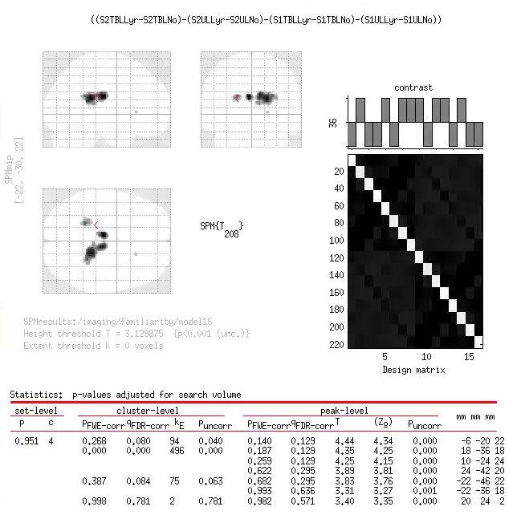
fornix?
Striatum?
Activation in the ventricles...
Individual comparisons in interaction
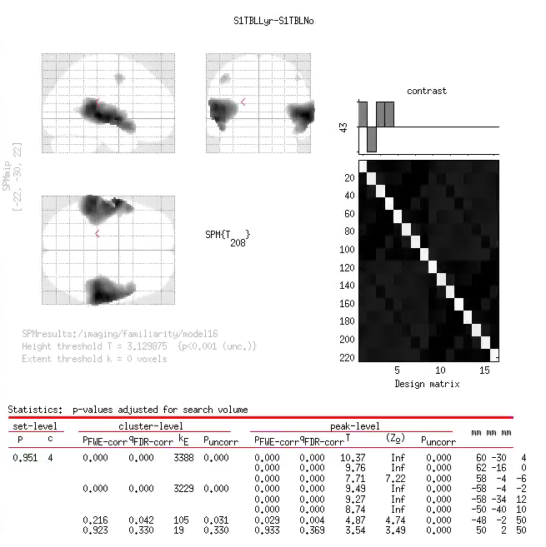
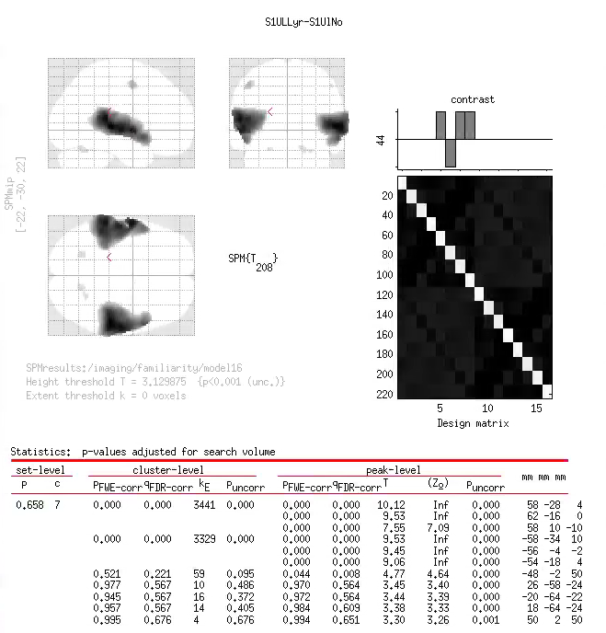
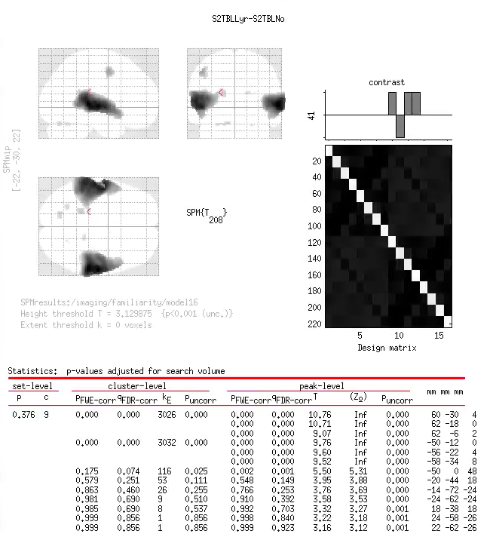
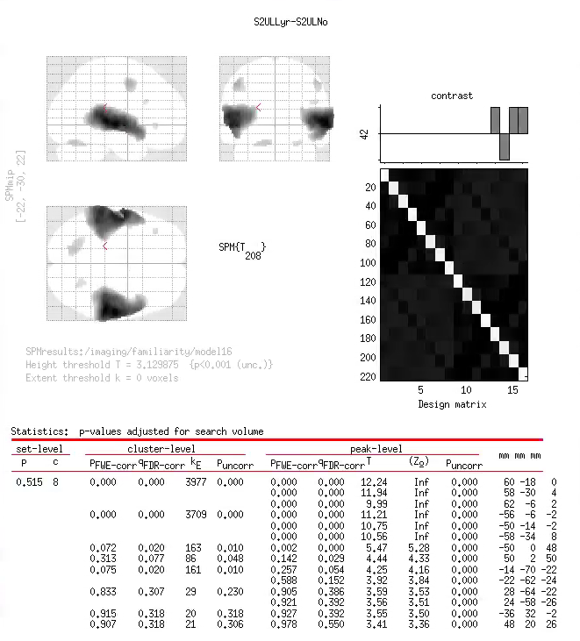
Auditory cortex
Breakdown of interaction
Session 2 Lyrics x Learning
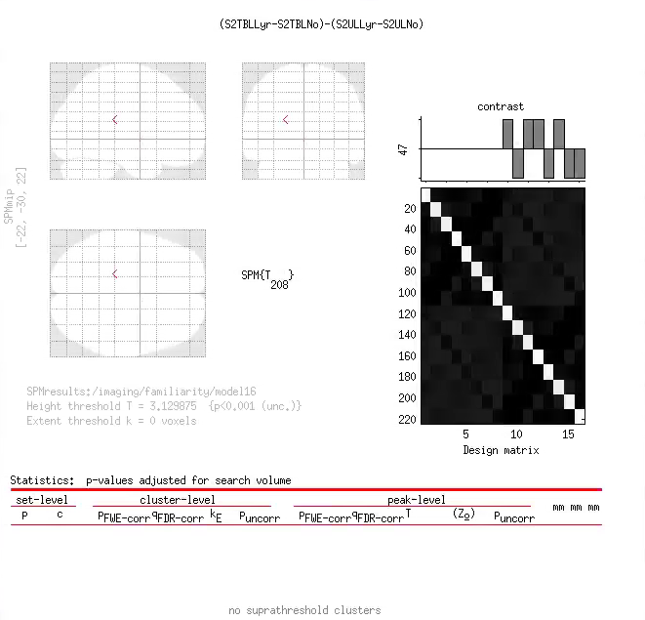

Session 1 Lyrics x Learning
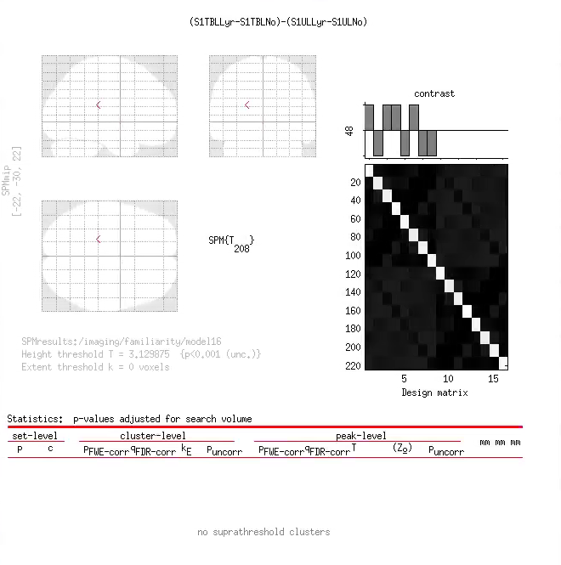
Unlearned Songs
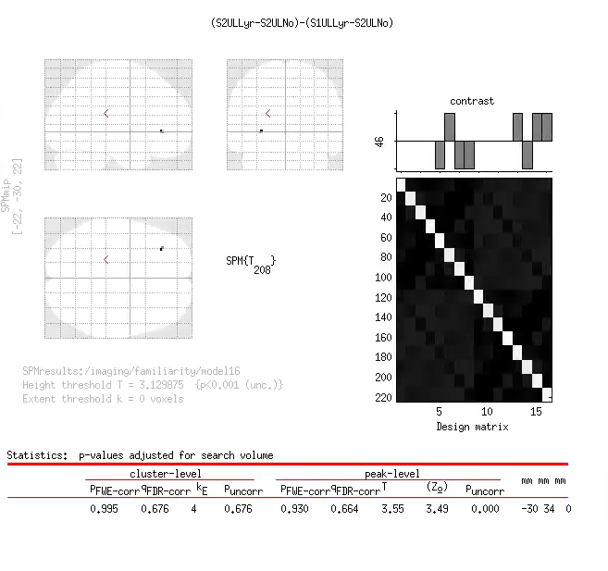
Session 2/Session 1 x Lyrics/NoLyrics

Learned Songs
Session 2/Session 1 x Lyrics/NoLyrics
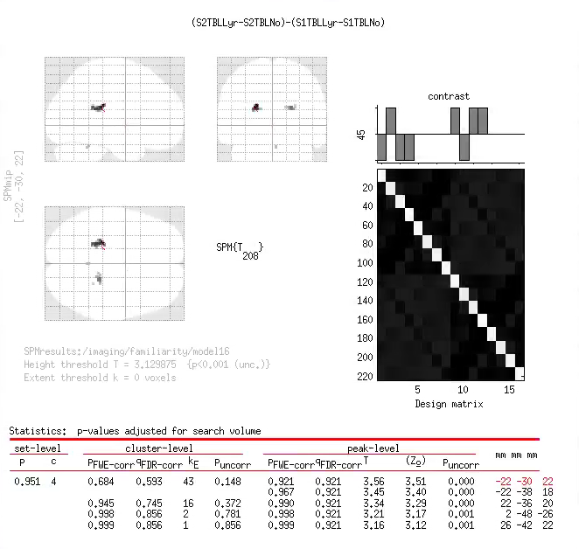

Striatum

